**ASTA SAMURAI WARRIOR TUTORIAL**

1. **Game Description**

This game made in Unity 5.6.0 that means same code can be targetted platforms **Itunes**, **GooglePlay,** etc.

1. **Tutorial Reskin**
2. **Setup characters**

Edit character prefabs in “Assets\ASTA\Prefabs\Player1”

“Assets\ASTA\Prefabs\Player2”

“Assets\ASTA\Prefabs\Enemy”

Create boss and more enemies. Add component in new prefabs.

Using component: Capsule Collider

Rigidbody

Health System

Enemy AI

Examp: “Assets\ASTA\Prefabs\Enemy Boss 1”

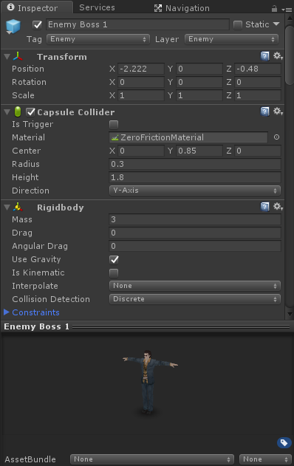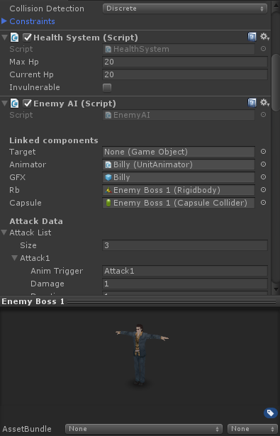

Edit characters information (Open character prefabs):

Health: Edit Max HP and Current HP

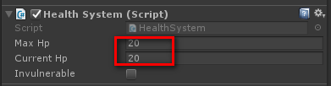

Movement system: Edit component Player Movement (with player) and Enemy AI (with Enemy). Damage, walk speed, time knockdown, combo skill, etc.

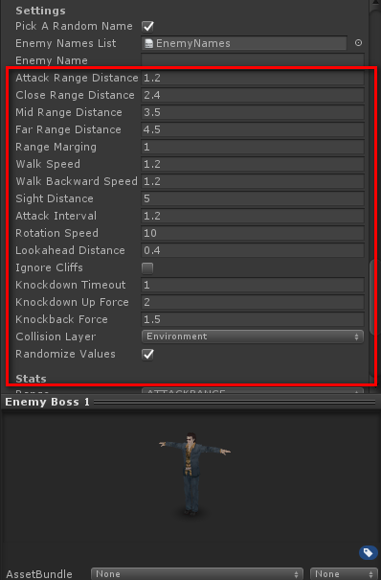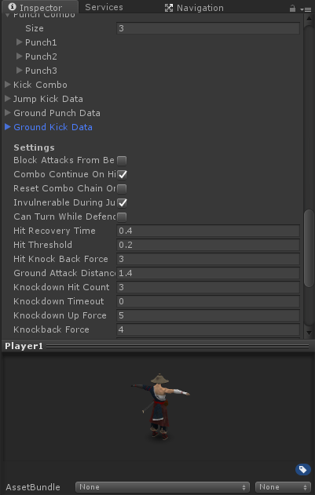

1. **Level Setting:**

Each level, you can sliced to many zone.

Edit “EnemyWaveSystem”:

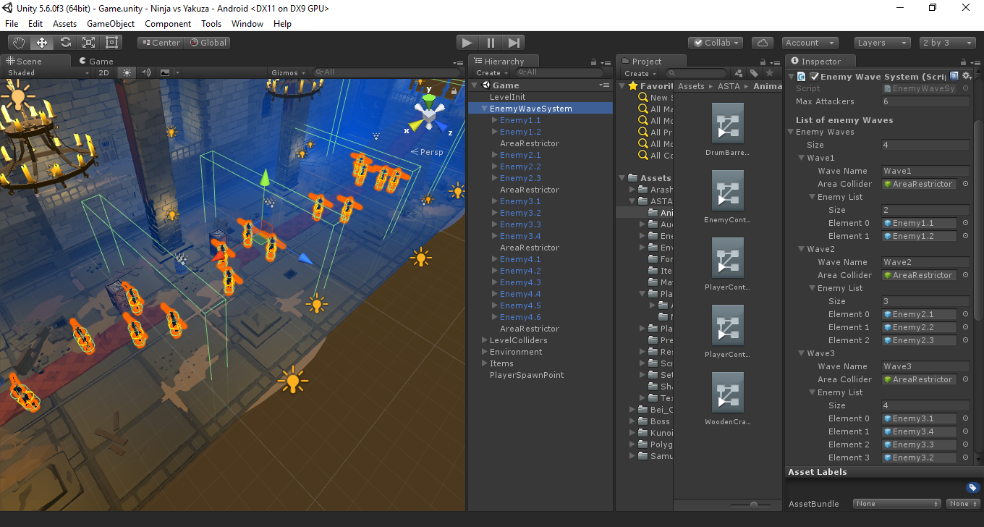

Examp: Wave1 have two enemy, Wave2 have three, Wave3 have four, etc...

* Load Level on Finish: EnemyWaveSystem -> write level name (correct name scene)

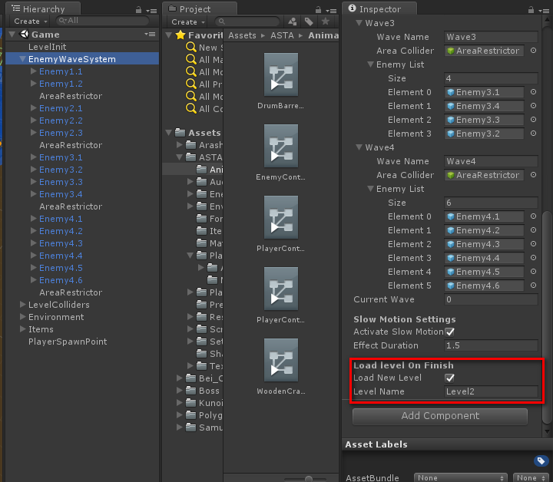

1. **Google Analytic:**

Window -> Google Analytics -> Edit Setting

Replace Account Name and Tracking ID

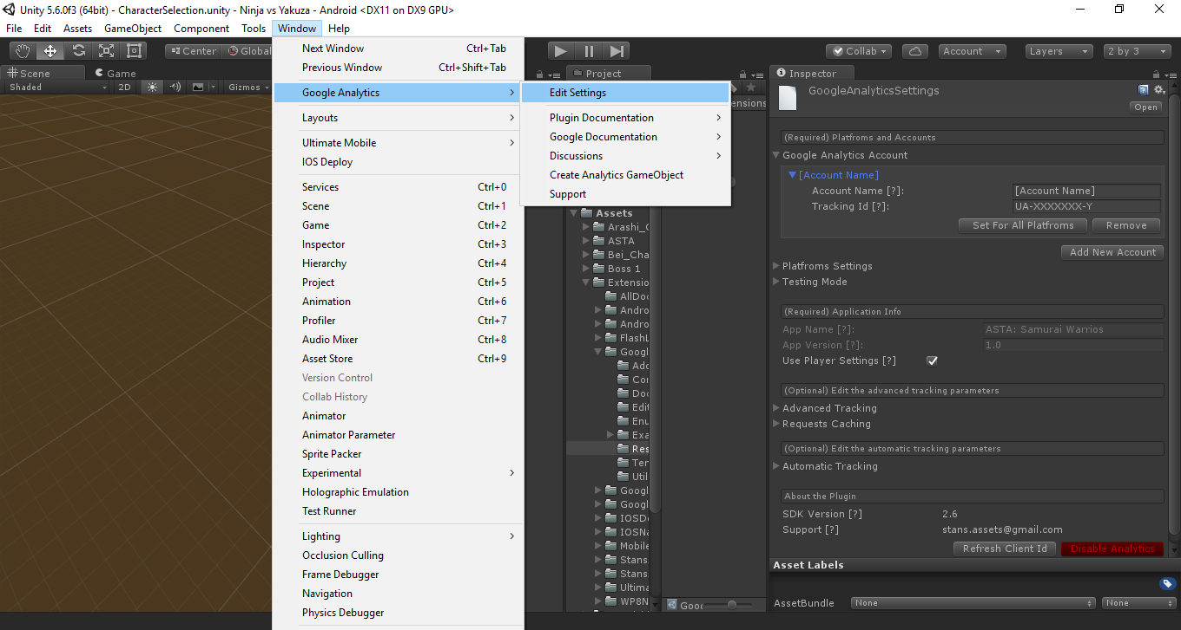

1. **Advertisement:**

Window -> Ultimate Mobile -> Edit Settings

Replace Advertisement ID

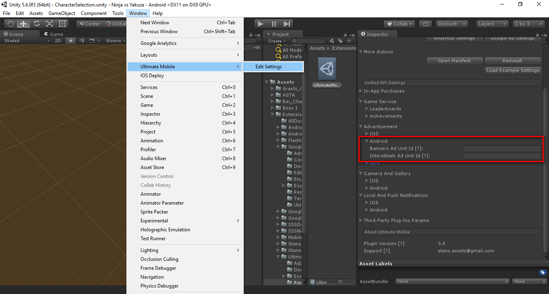

Chartboost:

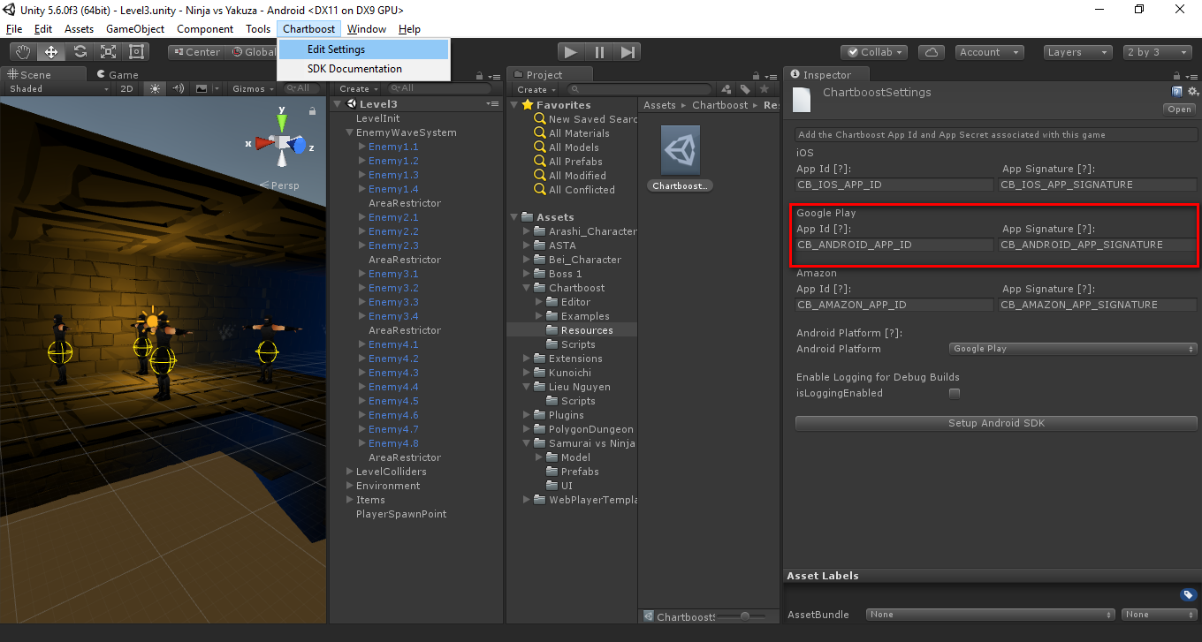

1. **Build Settings**

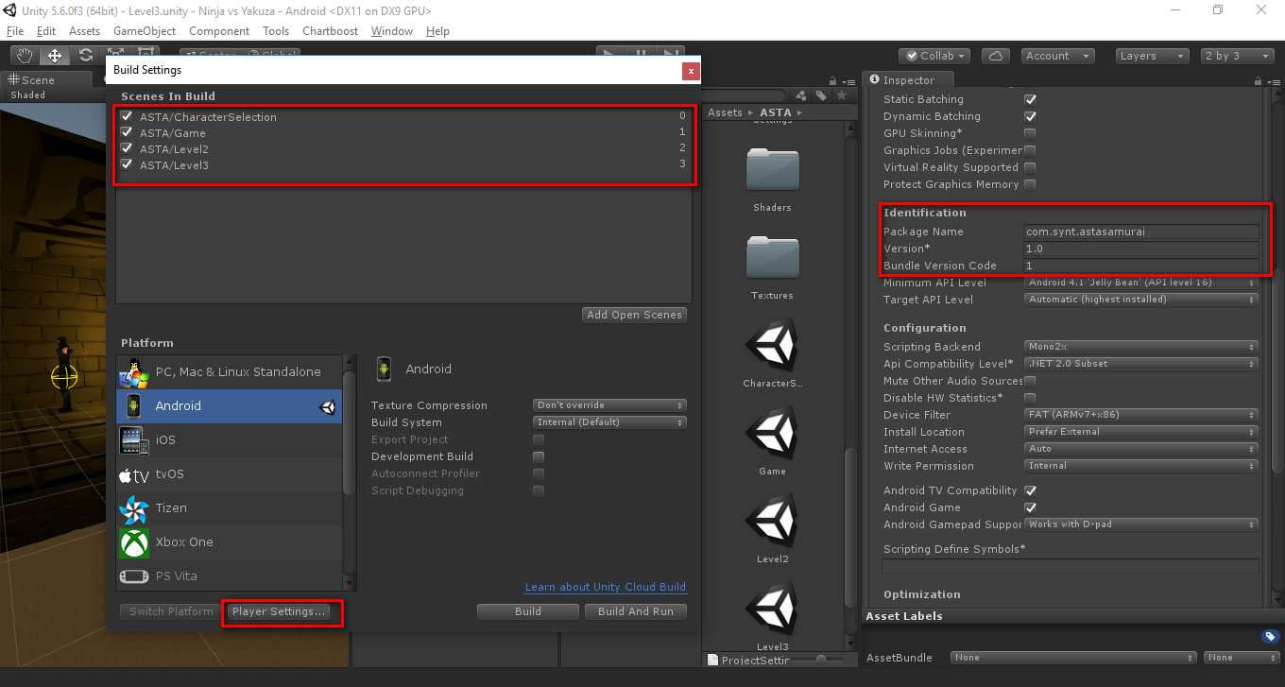

**THANK YOU FOR YOUR PURCHASE!**